Keeping A House Safe For A Guide Dog
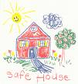
Module 3 Guide Dogs

A guide dog must have a safe environment to live in. What are some of the potential hazards a guide dog may encounter in different parts of a home?
Once you have listed these, see if you can come up with an improvement for each situation.

Garden and Shed

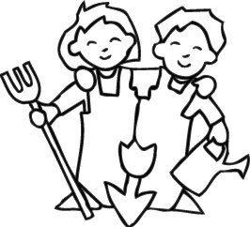

Hazards | Improvements

Kitchens

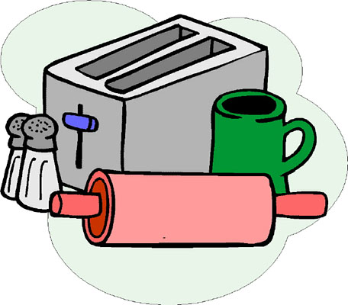

Hazards | Improvements

Bathrooms

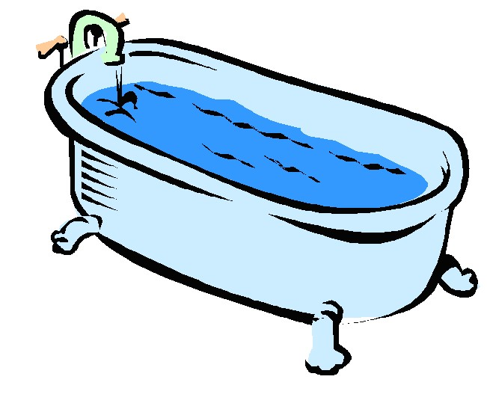

Hazards | Improvements

Bedrooms

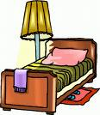

Hazards | Improvements

Living areas



Hazards | Improvements

Car

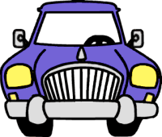

Hazards | Improvements

When walking

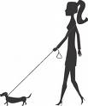

Hazards | Improvements

ANSWERS - Hazards

Garden and shed

- Things to chew on that may get lodged in dogs throat
- Toxic plants
- Spider bites
- Sharp tools, nails
- Areas that contain heat or little shade
- Not enough water to drink
- Toxic chemicals for use in garden or car

Kitchen

- Cupboards and drawers containing hazardous items
- Electrical cords
- Toxic chemicals
- Small spaces to get stuck

Bathrooms

- Access to water that could cause drowning
- Toxic chemicals, cosmetics
- Things to chew like hairbrushes

Bedrooms

- Cupboard access
- Cords

Living areas

- Heavy furniture that could be toppled over
- Cords

Car

- Safe for travel
- Out of sunlight
- Heat

Out walking

- Lack of water for long walks
- Identification
- Eating things off the ground

© 2007 Association for the Blind of Western Australia
Exceptions: Images
© Microsoft Office Clip Art 2007

